Advancing Road Safety: A Comparative Analysis of YOLO v8 an v5 for Real-Time Traffic Sign Detection and Recommendation

Aditya Samarbahadur Yadav   
Department of Computer Engineering Agnel Institute of Technology and Design

Mapusa, India   
[21co02@aitdgoa.edu.in](mailto:21co02@aitdgoa.edu.in)

Basil Jose

Dept. Computer Engineering

Agnel Institute of Technology and

Design

Mapusa, India

[bj@aitdgoa.edu.in](mailto:bj@aitdgoa.edu.in)

Gurudatta Alias Omkar Kishor Kinlekar  
Department of Computer Engineering Agnel Institute of Technology and Design

Mapusa, India   
[21co26@aitdgoa.edu.in](mailto:21co02@aitdgoa.edu.in)

Vishal Vittal Kumbhar

Department of Computer Engineering Agnel Institute of Technology and Design

Mapusa, India

[22lco04@aitdgoa.edu.in](mailto:22lco04@aitdgoa.edu.in)

Sweta Kamat

Department of Computer Engineering Agnel Institute of Technology and Design

Mapusa, India

[svk@aitdgoa.edu.in](mailto:svk@aitdgoa.edu.in)

***Abstract*— In the era of automation, road safety remains a critical challenge despite technological advancements. This research addresses the gap by proposing a real-time Traffic Sign Detection and Recommendation System (TSDRS) designed to enhance driver awareness and road safety. Leveraging the state-of-the-art YOLOv8 architecture, the system identifies and classifies traffic signs into three categories—cautionary, mandatory, and informatory—even under challenging conditions such as low-light environments, occlusions, and dynamic weather.**

**The methodology integrates advanced preprocessing techniques, including resizing, rotation, and noise addition, to augment dataset diversity and model robustness. A comparative analysis between YOLOv8 and YOLOv5n is conducted using a custom dataset comprising 780 annotated traffic sign images. Performance metrics such as mAP, precision, recall, and F1-score demonstrate YOLOv8’s superiority, achieving a mean average precision (mAP@0.5) of 92.89% for Speed Limit 100 signs, outperforming YOLOv5n by 40.09%. The system’s real-time efficacy is further enhanced through text-to-speech integration, providing auditory alerts to mitigate visual distractions.**

**Results highlight YOLOv8’s anchor-free detection head and optimized feature fusion as key contributors to its accuracy, with an overall mAP improvement of 15–30% across traffic sign categories compared to YOLOv5n. This innovation not only advances intelligent transportation systems but also supports autonomous vehicle development by ensuring reliable sign recognition in diverse scenarios. The study underscores YOLOv8’s potential to streamline traffic management, reduce manual intervention, and foster safer road networks globally.**

Keywords—traffic sign, traffic sign detection, YOLO, deep learning, real time detection

# Introduction

Traffic signs are essential components of transportation systems, ensuring the safety and efficiency of road networks by providing critical information to drivers and autonomous vehicles alike [1][2]. Reducing accidents, improving driver assistance technology, and improving navigation all depend on accurate traffic sign detection and recognition [2][3]. However, under difficult circumstances like dim lighting, fluctuating weather, and occlusion, conventional traffic sign recognition techniques—which mostly rely on manual inspection and feature extraction based on shape or color—frequently fail [1][3].By using convolutional neural networks (CNNs) to automatically extract reliable features from a variety of datasets, deep learning has revolutionized traffic sign detection and recognition [2][3]. State-of-the-art models, including YOLO, Mask R-CNN, and SSD, offer unparalleled accuracy and real-time performance, effectively addressing the complexities of multi-class traffic sign detection [1][2]. Preprocessing techniques like data augmentation, including rotation, flipping, and resizing, enhance the model’s ability to generalize across diverse scenarios [3].Despite advancements, challenges remain in handling high intra-class variability, low inter-class distinction, and the integration of recognition systems into real-world applications such as autonomous vehicles or intelligent transportation systems (ITS) [2][3]. In order to overcome these obstacles, this study suggests utilizing YOLOv8, expanding on earlier research that shows how successful CNN-based methods are [1][3]. By enabling automated traffic sign inventory and maintenance systems, the results could enhance infrastructure management in addition to traffic safety [2][3].

To overcome the difficulties in identifying and detecting traffic signs, the proposed project leverages advanced deep learning models, particularly the YOLO family of architectures, for robust traffic sign identification. The initiative focuses on utilizing the latest YOLO variants, including YOLOv8n and its predecessors (YOLOv5, YOLOv4, and YOLOv3), to classify and detect traffic signs under diverse environmental and operational conditions. These models are designed to achieve high precision, recall, and efficiency, addressing the complexities of real-time recognition in challenging scenarios such as occlusions, poor lighting, and high-speed environments.By employing these state-of-the-art YOLO models, the proposed solution aims to revolutionize traffic management systems, ensuring enhanced road safety and navigation reliability. By offering reliable detection systems that can manage a high degree of fluctuation in traffic sign appearances, the project helps the development of autonomous cars and is in line with the improvements in intelligent transportation systems (ITS).

The subsequent sections of this paper detail the methodologies adopted, comparative performance analysis of various YOLO models, and the results obtained.Collectively, these demonstrate how well this novel strategy advances traffic sign detection and identification systems. The project also highlights its broader implications, including streamlining traffic inventory management, reducing manual efforts, and supporting smart city initiatives. Through this technological innovation, it paves the way for safer and more efficient transportation networks globally.

# RELATED WORK

This part includes a literature review on traffic sign detection techniques, focusing on YOLO models. It also describes diverse solutions that have been developed in this area.

Kumaravel et al. [1] developed a region-based CNN model tailored to Indian traffic signs using advanced data augmentation techniques like flipping, cropping, and rotation, achieving high precision on real-world datasets. Tabernik and Skocāj [2] enhanced Mask R-CNN with Online Hard-Example Mining (OHEM), weighted samples, and a robust augmentation pipeline, achieving error rates below 3% on the DFG dataset. Zhu and Yan [3] compared YOLOv5 and SSD models, with YOLOv5 achieving superior mAP (97.7%) and speed, validating its real-time suitability. Ren et al. [4] introduced HFFT-YOLO, improving feature extraction for small targets, achieving 92.9% AP on the TT100K dataset. Xie and Weng [5] proposed lightweight ENet and EmdNet for efficient classification and detection, achieving 98.6% accuracy on GTSRB. Yang [6] optimized YOLOv3 with inception modules for better detection under challenging conditions.

Fleyeh et al. [7] combined Adaboost classifiers with Circular Hough Transform for robust detection under varying conditions, achieving a 98.4% recognition rate. Liu et al. [8] used multiblock normalization patterns and cascade tree structures, achieving over 95% accuracy on GTSDB with real-time processing. Kamal et al. [9] introduced SegU-Net with advanced loss functions, excelling in small sign detection on CURE-TSD and GTSDB datasets. Biswas et al. [12] tailored YOLOv8 for Indian traffic signs, achieving high precision in real-time detection amidst occlusions.

Mahadshetti et al. [13] proposed Sign-YOLO, integrating attention mechanisms for degraded traffic sign quality assessment, achieving 99.1% mAP on GTSDB. Song et al. [14] created BlockNet and R-CNN to accurately and reliably identify fragmented signs in panoramic photos. Kandasamy et al. [16] introduced TrafficSignNet, achieving 98.5% accuracy under varied lighting. Shahud et al. [17] and Wei et al. [18] addressed occlusions and real-world variations with tailored YOLOv3 and transfer learning models, demonstrating robust performance.

Rahul Kumar et al. [19] highlighted YOLOv8's efficiency in handling lighting and angle variability, achieving 93.5% accuracy in real-time operations. Anandhi et al. [20] used a modified LeNet-5 architecture for robust sign detection under diverse weather conditions. Luo et al. [21] proposed a multi-task CNN refining ROIs for dynamic real-world detection. Gore et al. [22] and Zhu and Yan [23] emphasized YOLOv5's superior performance in low-visibility scenarios, with mAP values of 81.7% and 97.7%, respectively.

# METHODOLOGY

## Dataset Creation

The dataset is created by collecting images from Roboflow Universe and Stock images for traffic sign detecting. Images of different traffic signs such as informatory, prohibitory, mandatory and cautionary have been gathered for training and testing deep learning models like YOLOv5 and YOLOv8, enabling a comparative study of the models. In this dataset, there are approximately 130 images of each kind of traffic sign, which are further distributed into 100, 10, and 20 images for training, testing, and validation respectively. The training to validation to test image ratios for the YOLOv5 and YOLOv8 models are approximately 76.9%, 15.5%, and 7.6%, respectively. The goal of this balanced distinction is to provide sufficient data for the models to successfully learn, validate, and test their performance effectively. The addition of these specific traffic sign allows for the assessment of the models’ abilities in recognizing and distinguishing between different traffic signs.

A number of data preparation methods were used to further improve the data set's quality. Initially, the pictures were all downsized to 640 pixels. Secondly, data augmentation strategies such as rotation (clockwise, counterclockwise, and upside-down) and flipping (vertical and horizontal) were employed to increase diversity. All approaches combined to significantly improve the overall quality and diversity of the dataset.

## Yolo v8

An enhanced convolutional neural network called the YOLO model was created for object recognition and localization in real time.. It integrates object classification and detection into a single regression process, unlike traditional methods that rely on region proposal networks. Instead of using a region proposal network, YOLO uses regression to directly translate image pixels into bounding box coordinates and class probabilities. This approach greatly increases detection speed at the expense of some precision. Each cell in the M × M grid created by YOLO is tasked with identifying objects whose centers fall inside its borders. The model produces bounding boxes and confidence ratings for every grid cell, which show how likely it is that an object will be there. Taking into account class numbers, coordinates (center, width, and height), and confidence scores, YOLO employs five anchor boxes per cell. One of YOLO's special features is its capacity to use a single neural network throughout the image, accelerating the detection process by predicting bounding boxes and probability for different regions in a single forward pass.

However, the most recent iteration of the YOLO series, YOLOv8, offers a number of improvements in terms of precision, speed, and effectiveness. With a simplified architecture, YOLOv8 streamlines the model design by using a single-stage approach for simultaneous feature extraction, object localization, and class probability prediction. Its upgraded backbone includes convolutional layers and residual connections to better understand features, while the "Focus" module facilitates efficient feature fusion, resulting in more accurate object detection. The model’s refined head design, which includes a revised anchor box selection mechanism and a multi-scale prediction strategy, improves its ability to recognize objects across varying sizes and scales. YOLOv8 offers notable performance improvements, including higher accuracy, faster inference, and better memory efficiency. Its flexibility is further demonstrated through multiple pre-trained model sizes, allowing users to select the one that fits their specific requirements and hardware capabilities. YOLOv8 is therefore a strong and adaptable object detection tool.

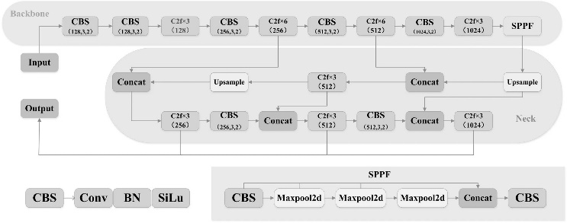

Fig. 1. YOLO v8 Framework

The YOLOv8 framework, shown in Figure 1, represents a significant advancement in object detection technology, incorporating the latest innovations. The core of the backbone network is designed to extract the most important information from input images. More accurate object recognition is facilitated by the neck layers, which improve feature extraction and transformation. Notably, YOLOv8 has a faster, anchor-free detecting head than its predecessors, which increases the precision of bounding box and class probability forecasts. A customized loss function optimizes the model’s parameters during training, ensuring strong performance across different hardware platforms. YOLOv8 is very accessible for a variety of applications due to its exceptional hardware flexibility and ability to function well across a range of devices. YOLOv8 is now a top option for contemporary object identification tasks in computer vision and intelligent systems because to these combined improvements, which also make it faster, more accurate, and more efficient.

## Yolo v5

YOLOv5 is a state-of-the-art deep learning model from the YOLO family of object detection algorithms. Its accuracy, speed, and lightweight construction make it popular for real-time object detection jobs. An input image is divided into a grid by YOLOv5, which then predicts bounding boxes and class probabilities for every grid cell. Key characteristics of YOLOv5 include its ability to adapt to a variety of applications and custom datasets, its enhanced architecture that incorporates cutting-edge components like CSPNet and PANet for improved performance, and its optimization for real-time applications through a small model size and quick inference.

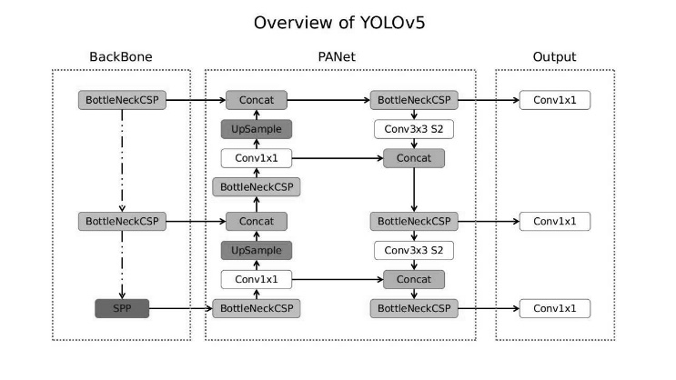

Fig. 2. YOLO v5 Framework

The architecture of YOLOv5 is composed of three main components: the Backbone, PANet (Path Aggregation Network), and the Output.The **Backbone** is responsible for extracting feature maps from the input image. It uses CSP (Cross-Stage Partial) Bottleneck layers, known as BottleneckCSP, to enhance feature learning while minimizing computational costs. At the end of the Backbone, a Spatial Pyramid Pooling (SPP) module is used to capture multi-scale features, which helps in detecting objects of various sizes effectively.The **PANet** facilitates feature fusion by integrating high-level and low-level features, ensuring better detection accuracy. This involves upsampling to pass features from deeper layers to shallower layers, concatenating features from different layers for richer context, and processing these features using Conv1x1 and Conv3x3 layers. The stride-2 (S2) convolution in Conv3x3 is particularly used to downsample the feature map for further processing.Finally, the **Output** stage takes the fused features and produces predictions for object detection. It can detect small, medium, and large items since it produces three sets of outputs at various scales. Conv1x1 layers are used in each output layer to effectively carry out bounding box regression and classification.

Figure 2 illustrates this architecture, which combines feature extraction, fusion, and prediction in an efficient manner, making YOLOv5 an excellent choice for real-time object recognition tasks. [30]

1. 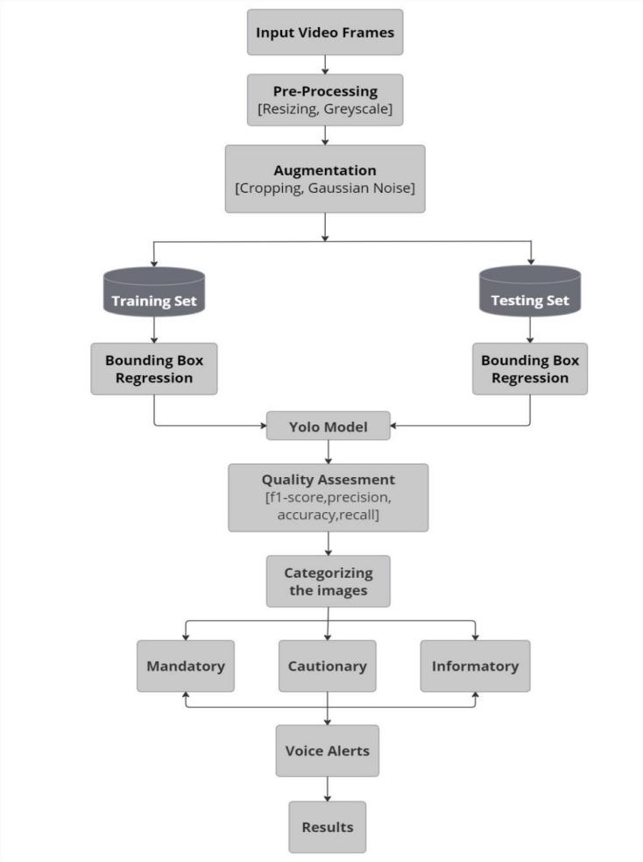

## Proposed Work

Fig. 3. Block diagram of proposed work

The suggested "Traffic Sign Detection and Recognition using YOLOv8" method outlines a methodical approach to automate the real-time identification and categorization of traffic signs. The primary inputs for detection in this procedure are input video frames, which can be taken from pre-recorded videos or live feeds. In order to reduce complexity, preprocessing involves scaling frames to the YOLOv8 model's input dimensions and, if desired, turning them into grayscale.

For improved robustness of the model, data augmentation methods like cropping or adding Gaussian noise simulate the creation of such a diverse training dataset that is used in training.After then, the dataset is divided into two sections: the training set and the testing set. The YOLOv8 model is trained on the training set to learn traffic sign-specific characteristics, and its performance is assessed on fresh data using the test set. In order to locate traffic signals in video frames that will subsequently be supplied to the YOLOv8 model for online detection, the final stage will involve the implementation of bounding box regression. Several traffic indicators are detected and categorized by the model in a single frame.

To ensure a dependable detection, the YOLOv8 model's performance is assessed using a variety of assessment measures, including accuracy, precision, recall, a measure.

The captured traffic signs are classified into three types: mandatory (for example, speed limits, no entry), cautionary (sharp turns, road humps), and informational (hospital ahead, parking areas). Besides, it helps drivers by providing real-time voice alerts upon detection of these road signs, thus improving road safety. The final output includes video frames with highlighted bounding boxes around detected signs, categorized results, and voice recommendations, which makes the system pragmatic and effective in real-time traffic scenarios. This methodology effectively combines pre-processing, augmentation, detection based on YOLOv8, and categorization to realize efficient traffic sign recognition with voice alert integration.

# RESULTS AND DISCUSSION

## Performance Metrics

The network performance of the traffic sign detection and recommendation model is assessed using a range of performance metrics such as detection speed, recognition accuracy, and overall efficiency, to ensure its suitability for real-time use. Model are evaluated with respect to the following:

*1) Precision:* Measures the accuracy of positive predictions. It is the proportion of accurately predicted favorable outcomes to all of the good outcomes that were projected. False Positives are inaccurate positive predictions, while True Positives are instances where the model accurately detects positives, as defined in equation (1).

*[12] (1)*

*2) Recall (True Positive Rate or Sensitivity):* Measures the proportion of actual positive cases correctly identified by the model. False Negatives are cases where actual positives are incorrectly classified as negatives, as defined in equation (2).

*[12] (2)*

*3) F1 Score:* Combines precision and recall into a single metric to evaluate overall performance, especially for imbalanced datasets. It is the precision and recall harmonic mean. According to equation, a high F1 score denotes effective model performance, which is a compromise between precision and recall. (3).

[12] (3)

*4)mAP(Mean* Average Precision): mAP is used to evaluate the average performance of the model to detect all categories. It is the average of the values of all categories, as defined in equation (5).

*[30] (4)*

where the value Pr(I) means the area under the curve of precision-recall for each of the five traffic signs, with consideration given to an Intersection over Union (IoU) of 0.50. Here, (I) signifies the specific traffic sign being evaluated. The IoU, defined in equation (6), measures the overlap between predicted and actual bounding boxes, providing insights into the accuracy of object localization.

[30] (5)

[30] (6)

## Proposed Results

Implementation showcases how YOLOv8n and YOLOv5n excel in specific precision and accuracy aspects, empowering researchers to choose the ideal model based on their traffic sign related needs.

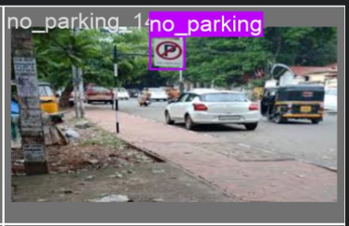 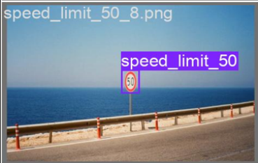

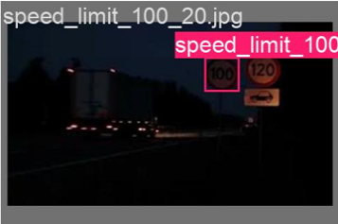 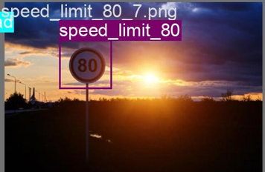

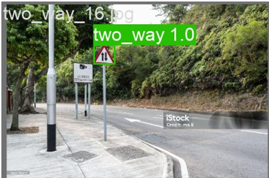 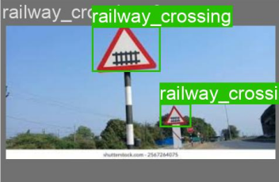

1. Detection of Traffic Sign using YOLO v8n.

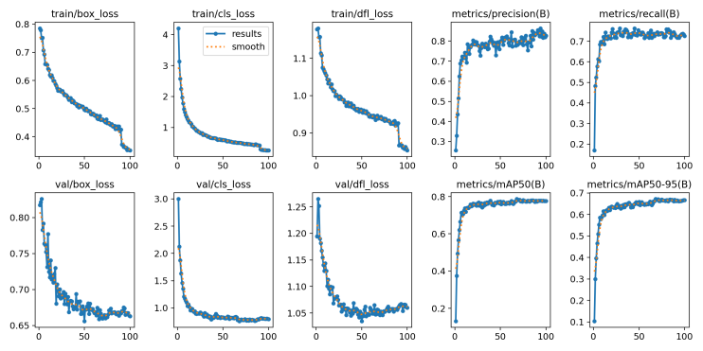

1. Training and Validation Metrics Of YOLO v8n.

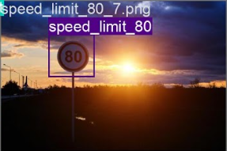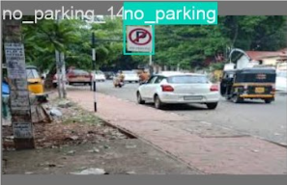 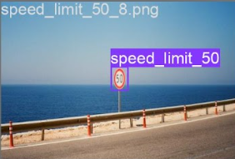

 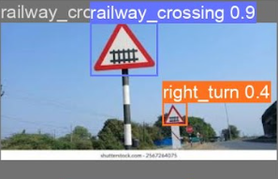

1. Detection of Traffic Sign using YOLO v5n.

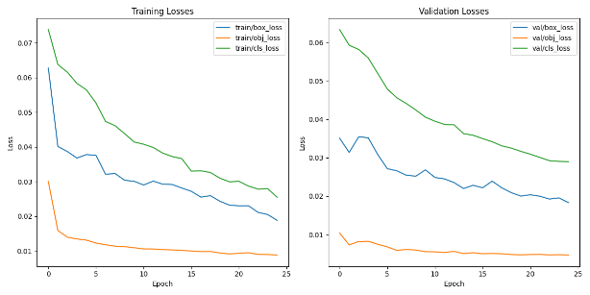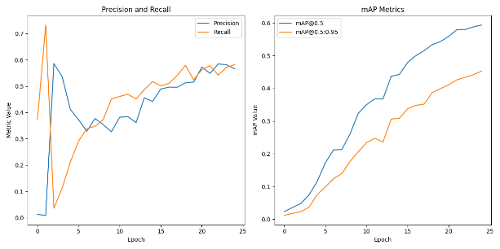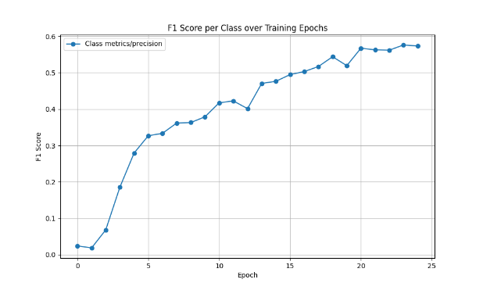

1. Training and Validation Metrics Of YOLO v5n.

Figure 4 and Figure 6 show examples of detected images from six different traffic signs namely no parking,speed limit 50,speed limit 100,speed limit 80 ,two way and railway crossing using YOLO v8 and YOLO v5 respectively.

Comparison of traffic signs based on different measures using YOLO v8 along with YOLO v5 as follows:

1. COMPARISON TABLE FOR NO PARKING SIGN.

|  |  |  |
| --- | --- | --- |
| MEASURES | YOLO v8n | YOLO v5n |
| mAP | 0.9091 | 0.633 |
| Recall | 0.909 | 0.673 |
| Precision | 0.8969 | 0.63 |
| F1-Score | 0.8873 | 0.6508 |

1. COMPARISON TABLE FOR SPEED LIMIT 50 SIGN.

|  |  |  |
| --- | --- | --- |
| MEASURES | YOLO v8n | YOLO v5n |
| mAP | 0.9214 | 0.325 |
| Recall | 0.55 | 0.55 |
| Precision | 0.9691 | 0.212 |
| F1-Score | 0.9106 | 0.3060 |

1. COMPARISON TABLE FOR SPEED LIMIT 80 SIGN.

|  |  |  |
| --- | --- | --- |
| MEASURES | YOLO v8 | YOLO v5n |
| mAP | 0.8500 | 0.357 |
| Recall | 0.7951 | 0.4 |
| Precision | 0.8197 | 0.229 |
| F1-Score | 0.7993 | 0.2913 |

1. COMPARISON TABLE FOR SPEED LIMIT 100 SIGN.

|  |  |  |
| --- | --- | --- |
| MEASURES | YOLO v8 | YOLO v5n |
| mAP | 0.9289 | 0.528 |
| Recall | 0.85 | 0.4 |
| Precision | 0.854 | 0.545 |
| F1-Score | 0.9126 | 0.4614 |

1. COMPARISON TABLE FOR TWO WAY SIGN.

|  |  |  |
| --- | --- | --- |
| MEASURES | YOLO v8 | YOLO v5n |
| mAP | 0.8947 | 0.623 |
| Recall | 0.6024 | 0.412 |
| Precision | 0.8998 | 0.581 |
| F1-Score | 0.7740 | 0.4821 |

1. COMPARISON TABLE FOR Railway crossing sign.

|  |  |  |
| --- | --- | --- |
| MEASURES | YOLO v8 | YOLO v5n |
| mAP | 0.9797 | 0.96 |
| Recall | 0.7791 | 0.847 |
| Precision | 0.9773 | 0.978 |
| F1-Score | 0.9520 | 0.9078 |

The findings of the traffic sign detection and comparison between YOLOv8 and YOLOv5n show a clear difference in performance across various signs. YOLOv8 achieves a greater mAP score for most traffic signs, such as No Parking, Speed Limit 50, and Two-Way signs. YOLOv5n, however, performs lower, with mAP values of 0.633, 0.325, and 0.623, whereas YOLOv8 achieves mAP scores of 0.9091, 0.9214, and 0.8947, respectively. This is evident in TABLE I, TABLE II, and TABLE V.

YOLOv8 demonstrates outstanding accuracy across different traffic signs. It performs exceptionally well in detecting Speed Limit 100 and Railway Crossing signs. YOLOv8 surpasses YOLOv5n by 0.4009 in mAP for the Speed Limit 100 sign and achieves an F1-score of 0.9126, while YOLOv5n only scores 0.4614. For the Railway Crossing sign, YOLOv8 maintains a high mAP of 0.9797, slightly outperforming YOLOv5n’s 0.96, as seen in TABLE IV and TABLE VI.

YOLOv8’s precision is superior for multiple types of signs. It particularly excels in detecting Speed Limit 50 and Speed Limit 80 signs. YOLOv8 outperforms YOLOv5n by 0.9106 in F1-score for Speed Limit 50 and 0.7993 for Speed Limit 80, while YOLOv5n only achieves 0.3060 and 0.2913, respectively. This is reflected in TABLE II and TABLE III.The results indicate that YOLOv8 consistently surpasses YOLOv5n in all key metrics—mAP, Recall, Precision, and F1-score—across all traffic sign categories. This confirms YOLOv8 as a more reliable model for accurate and efficient traffic sign detection, as seen in TABLE I through TABLE VI.

The model is compared to state-of-the-art techniques with advanced algorithms like YOLOv11,and YOLOv7. YOLOv11 achieved a low mAP value of 75.66% for different traffic sign identification, while YOLOv7 achieved an excellent IoU result of 60.31% for railway crossing sign recognition. For railway crossing sign detection, YOLOv11 achieved a decent IoU value of 90.6%, whereas YOLOv5 achieved an excellent mAP value of 96% for correctly identifying railway crossing signs. But the main goal of this research is to compare various models and check which model gives best results for our custom dataset. The models that perform best for the task are YOLOv8 and YOLOv11 , with mAP values of 77.73% and 75.66%, respectively.

In addition, comparing YOLOv8 and YOLOv11 highlights significant variations in traffic sign specific performance, highlighting the advantages and disadvantages of each model and providing informative advice on which method is best for traffic sign detection tasks.

The comparison of YOLO v8 and YOLO v5 for the traffic sign identification shows that both the deep learning models have shown very excellent results but YOLOv8 got higher mAP scores overall while YOLO v5 showcased better precision for some traffic signs. The results of deep learning show that it is a very good substitute for the traffic sign identification processes, bringing such many advantages as increased efficiency, labour cost reduction, and also better traffic regulation in the traffic cell field. The drawbacks of the study include emphasizing only some specific traffic signs. To increase the models' capacity for generalization, however, a great deal more study should be done to broaden the scope of the traffic sign under investigation. The suggestions include adopting data augmentation techniques for increased accuracy and refining the current models for various datasets and real-world scenarios. The comparative analysis of the available models provides valuable information for selecting the best model for a given task, emphasizing the importance of taking accuracy and precision into account when choosing a model to improve automated traffic sign identification systems for real-time traffic sign identification.

# CONCLUSION

In order to preserve road safety and guarantee efficient transportation networks, traffic signs are crucial. Automated detection is essential for real-time applications since manual traffic sign identification and classification can be laborious and error-prone. In this work, two deep learning models—YOLO v8 and YOLO v5—for real-time traffic sign detection and suggestion are compared.The outcomes show a distinct difference in the two models' performance for various traffic indicators. YOLO v8 consistently outperforms YOLO v5 in terms of mAP, precision, recall, and F1-score for most traffic signs, such as No Parking, Speed Limit 50, and Speed Limit 100. For instance, YOLO v8 achieves an mAP of 0.9289 for Speed Limit 100, compared to 0.528 for YOLO v5n. Additionally, in cases like Railway Crossing and Two-Way signs, YOLO v8 shows superior accuracy, making it a more reliable choice for real-time traffic monitoring. Given its higher precision and overall performance, these results imply that YOLO v8 is more appropriate for real-time traffic sign identification. As a result, it is the best option for intelligent transportation systems where quick and precise detection is crucial.

However, YOLO v5 may still be useful in scenarios where computational efficiency is a priority. Future work could focus on optimizing these models by considering dataset size, computational constraints, and deployment strategies to enhance real-world applicability in intelligent traffic management systems.

##### References

1. T. Kumaravel, Sathishkumar V. E, P. Natesan, S. Dharanesh, G. Hariharan and N. Krishnamoorthy, “Indian traffic sign detection and recognition using deep learning”. Proceedings of the 2023 International Conference on Machine Learning and Automation research gate.DOI: 10.54254/2755-2721/30/20230062
2. Domen Tabernik and Danijel Skocaj,” Deep Learning for Large-Scale Trafc-Sign Detection and Recognition”. IEEE Transactions on Intelligent Transportation Systems PP(99):1-14 . DOI:10.1109/TITS.2019.2913588
3. Zhu, Y., Yan, W.Q. “Traffic sign recognition based on deep learning”. *Multimed Tools Appl* **81**, 17779–17791 (2022) springer. DOI:10.1007/s11042-022-12163-0
4. Bingyi Ren, Juwei Zhang and Tong Wang. “A Hybrid Feature Fusion Traffic Sign Detection Algorithm Based on YOLOv7”. Computers, Materials & Continua July 2024 research gate. DOI: 10.32604/cmc.2024.052667
5. X. Bangquan and W. Xiao Xiong, "Real-Time Embedded Traffic Sign Recognition Using Efficient Convolutional Neural Network," in *IEEE Access*, vol. 7, pp. 53330-53346, 2019, doi: 10.1109/ACCESS.2019.2912311.
6. Zhonglai Yang. “Intelligent Recognition of Traffic Signs Based on Improved YOLOv3Algorithm”. Mobile Information Systems 2022 research gate . DOI:10.1155/2022/7877032.
7. H. Fleyeh, R. Biswas and E. Davami, "Traffic sign detection based on AdaBoost color segmentation and SVM classification," *Eurocon 2013*, Zagreb, Croatia, 2013, pp. 2005-2010, doi: 10.1109/EUROCON.2013.6625255.
8. C. Liu, F. Chang and Z. Chen, "Rapid Multiclass Traffic Sign Detection in High-Resolution Images," in *IEEE Transactions on Intelligent Transportation Systems*, vol. 15, no. 6, pp. 2394-2403, Dec. 2014, doi: 10.1109/TITS.2014.2314711.
9. U. Kamal, T. I. Tonmoy, S. Das and M. K. Hasan, "Automatic Traffic Sign Detection and Recognition Using SegU-Net and a Modified Tversky Loss Function With L1-Constraint," in *IEEE Transactions on Intelligent Transportation Systems*, vol. 21, no. 4, pp. 1467-1479, April 2020, doi: 10.1109/TITS.2019.2911727.
10. F. Zaklouta and B. Stanciulescu, "Real-Time Traffic-Sign Recognition Using Tree Classifiers," in *IEEE Transactions on Intelligent Transportation Systems*, vol. 13, no. 4, pp. 1507-1514, Dec. 2012, doi: 10.1109/TITS.2012.2225618.
11. Manjiri Bichkar, Suyasha Bobhate, Prof. Sonal Chaudhari.”Traffic Sign Classification and Detection of Indian Traffic Signs using Deep Learning”. International Journal of Scientific Research in Computer Science, Engineering and Information Technology Volume 7, Issue 3 (2021) ISSN: 2456-3307.
12. S. Biswas, S. Acharjee, A. Ali and S. S. Chaudhari, "YOLOv8 based Traffic Signal Detection in Indian Road," *2023 7th International Conference on Electronics, Materials Engineering & Nano-Technology (IEMENTech)*, Kolkata, India, 2023, pp. 1-6, doi: 10.1109/IEMENTech60402.2023.10423520.
13. R. Mahadshetti, J. Kim and T. -W. Um, "Sign-YOLO: Traffic Sign Detection Using Attention-Based YOLOv7," in *IEEE Access*, vol. 12, pp. 132689-132700, 2024, doi: 10.1109/ACCESS.2024.3417023.
14. Song, Y., Fan, R., Huang, S. *et al.* “A three-stage real-time detector for traffic signs in large panoramas”. *Comp.Visual Media* **5**, 403–416 (2019) spinger. DOI:10.1007/s41095-019-0152-1.
15. Zhenguo Lu, Zhibo Zhu, Weipeng Xu, Guixian Li and Jinyang Chen. “Enhancing small target traffic sign detection with ML_SAP in YOLOv5s”. Scientific Reports vol.14 (2024) research gate. DOI: 10.1038/s41598-024-76804-0.
16. Kandasamy, K., Natarajan, Y., Sri Preethaa, K.R. *et al.* “A Robust TrafficSignNet Algorithm for Enhanced Traffic Sign Recognition in Autonomous Vehicles Under Varying Light Conditions”. *Neural Process Lett* **56**, 241 (2024) spinger.DOI: 10.1007/s11063-024-11693-y.
17. M. Shahud, J. Bajracharya, P. Praneetpolgrang and S. Petcharee, "Thai Traffic Sign Detection and Recognition Using Convolutional Neural Networks," *2018 22nd International Computer Science and Engineering Conference (ICSEC)*, Chiang Mai, Thailand, 2018, pp. 1-5, doi: 10.1109/ICSEC.2018.8712662.
18. L. Wei, L. Runge and L. Xiaolei, "Traffic sign detection and recognition via transfer learning," *2018 Chinese Control and Decision Conference (CCDC)*, Shenyang, China, 2018, pp. 5884-5887, doi: 10.1109/CCDC.2018.8408160.
19. Rahul Kumar, Aniket Gupta, Rajeswari D. “TRAFFIC SIGN DETECTION USING YOLOv8”. International Conference on Intelligent Data Communication Technologies and Internet of Things (2024) research gate. DOI:10.1109/IDCIoT59759.2024.10467849.
20. Ms.T.Anandhi, Ambati Manikanta vara prasad, Allam Chinna Sathya Sai Surendra Reddy.”TRAFFIC SIGNS RECOGNITION USING YOLO**”.** International Journal of Creative Research Thoughts Volume 12, Issue 4 April 2024 ISSN: 2320-2882.
21. H. Luo, Y. Yang, B. Tong, F. Wu and B. Fan, "Traffic Sign Recognition Using a Multi-Task Convolutional Neural Network," in *IEEE Transactions on Intelligent Transportation Systems*, vol. 19, no. 4, pp. 1100-1111, April 2018, doi: 10.1109/TITS.2017.2714691.
22. Shubham Gore, Manan Bhasin, Suchitra S. “Traffic Sign Detection using Yolo v5”. International Journal for Research in Applied Science & Engineering Technology (IJRASET**)** *Volume 11 Issue V May 2023 ISSN: 2321-9653.*
23. Zhu, Y., Yan, W.Q. “Traffic sign recognition based on deep learning”. *Multimed Tools Appl* **81** (2022) springer. DOI:10.1007/s11042-022-12163-0.
24. Fang S, Chen C, Li Z, Zhou M, Wei R.” YOLO-ADual: A Lightweight Traffic Sign Detection Model for a Mobile Driving System”. *World Electr. Veh. J.* **2024**, *15*, 323. DOI: 10.3390/wevj15070323.
25. Yaqin Wu, Wangli Hao, Jianjun Niu, Hao Wang. “YOLO-based lightweight traffi c sign detection algorithm and Mobile deployment”. Research Square (2024) research gate. DOI: 10.21203/rs.3.rs-4263773/v1.
26. Ming Li, Li Zhang, Linlin Li and Wenlong Song. “Yolo-Based Traffic Sign Recognition Algorithm”. Hindawi Computational Intelligence and Neuroscience Volume 2022. DOI: 10.1155/2022/2682921.
27. Y. Liu and P. Luo, "YOLO-TS: A Lightweight YOLO Model for Traffic Sign Detection," in *IEEE Access*, vol. 12, pp. 169013-169023, 2024, doi: 10.1109/ACCESS.2024.3498057.
28. Kshitij Dhawan, Srinivasa Perumal R, Nadesh R. K.” Identification of traffic signs for advanced driving assistance systems in smart cities using deep learning”. Multimedia Tools and Applications (2023) research gate. DOI:10.1007/s11042-023-14823-1
29. Niu M, Chen Y, Li J, Qiu X, Cai W. “YOLOv8s-DDA: An Improved Small Traffic Sign Detection Algorithm Based on YOLOv8s”.*Electronics* **2024**, *13*, 3764. DOI: 10.3390/electronics13183764
30. *P. Liu, Z. Xie and T. Li, "UCN-YOLOv5: Traffic Sign Object Detection Algorithm Based on Deep Learning," in IEEE Access, vol. 11, pp. 110039-110050, 2023, doi: 10.1109/ACCESS.2023.3322371.*